Task 3 – Automation with Crontab
Question 1
List 3 real-life scenarios where automating tasks with crontab would be useful on a Linux server, and write one line explaining the benefit for each.
1. Automatic System Backup
Crontab can automatically back up important files and directories every day, reducing the risk of data loss.
2. Log File Cleanup
Crontab can automatically delete or archive old log files to free disk space and keep the system organized.
3. Software Updates
Crontab can schedule automatic system or application updates during off-peak hours, improving security and reducing manual work.
2. Write a crontab entry that runs a script called update_playlist.sh every day at 2:00 AM to automatically update your music playlist backup, and explain what each part of the crontab line means.
Step 1: Create a Daily Crontab Entry
I created a cron job to execute the update_playlist.sh script automatically every day at 2:00 AM.
Commands:
crontab -e
Crontab Entry:
0 2 * * * /home/kali/update_playlist.sh
I verified the cron job using:
crontab -l
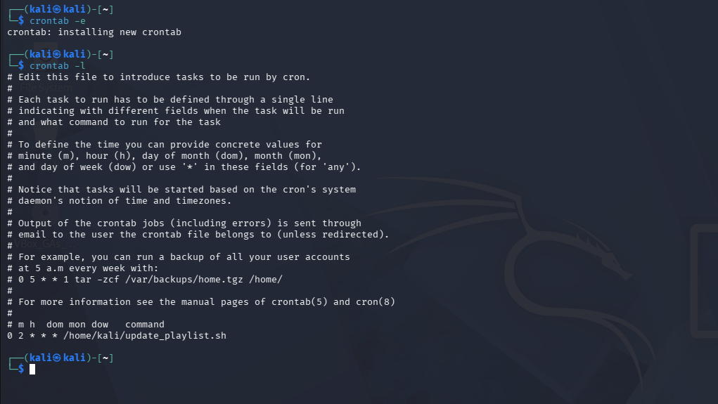
Question 3: Create a Backup Script
I created a shell script named backup_instagram_photos.sh to automatically back up the contents of the InstagramPhotos directory. The script creates a backup folder with the current date and copies all files into it.
Commands:
mkdir -p ~/InstagramPhotos
mkdir -p ~/Backups
nano ~/backup_instagram_photos.sh
chmod +x ~/backup_instagram_photos.sh
~/backup_instagram_photos.sh
Script Content:
#!/bin/bash
DATE=$(date +%F)
mkdir -p ~/Backups/InstagramPhotos_$DATE
cp -r ~/InstagramPhotos/* ~/Backups/InstagramPhotos_$DATE/
The backup was verified by listing the contents of the Backups directory.
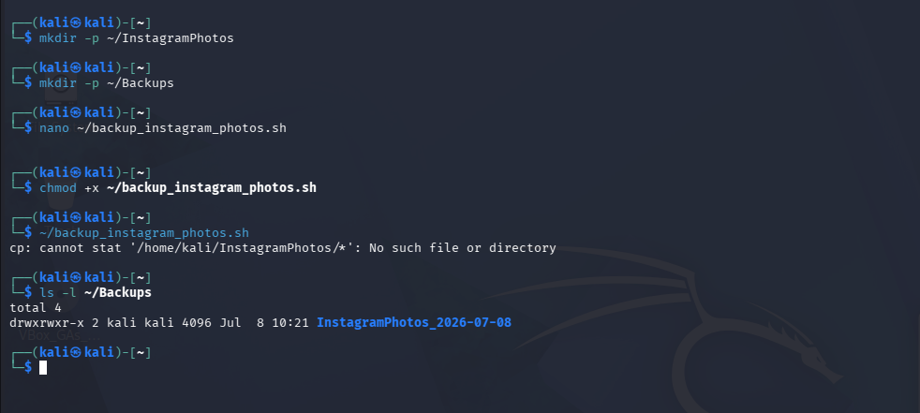

4.Schedule your backup_instagram_photos.sh script to run every Sunday at 11:30 PM using crontab, and redirect both standard output and errors to a log file named backup_log.txt in your home directory.
Commands:
crontab -e
Crontab Entry:
30 23 * * 0 /home/kali/backup_instagram_photos.sh >> /home/kali/backup_log.txt 2>&1
I verified the cron job using:
crontab -l
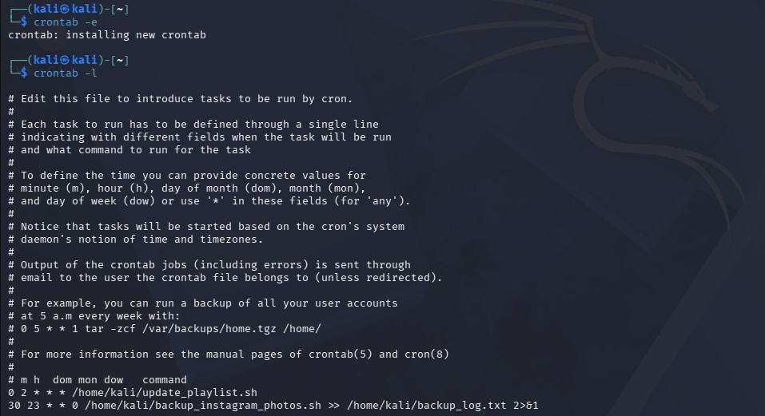
5. After your backup runs, open backup_log.txt and submit the last 5 lines as proof that your backup and logging worked.<br><br><em><strong>Hint:</strong> Use the tail command to view the last lines of your log.</em>
Step 1
Run the script manually and save the output to the log file:
~/backup_instagram_photos.sh >> ~/backup_log.txt 2>&1
Now view the last 5 lines of the log file:
tail -n 5 ~/backup_log.txt
